3. Prepare UML diagrams.
Prepare Activity diagram for given project.

When to use Activity Diagram?
Activity diagrams are useful in several scenarios, especially when you need to visually represent the flow of processes or behaviors in a system. Here are key situations when you should use an activity diagram:
- Modeling Workflows or Processes: When you need to map out a business process, workflow, or the steps involved in a use case, activity diagrams help visualize the flow of activities.
- Concurrent or Parallel Processing: If your system or process involves activities happening simultaneously, an activity diagram can clearly show the parallel flow of tasks.
- Understanding the Dynamic Behavior: When it’s essential to depict how a system changes over time and moves between different states based on events or conditions, activity diagrams are effective.
- Clarifying Complex Logic: Use an activity diagram to simplify complex decision-making processes with branching paths and different outcomes.
- System Design and Analysis: During the design phase of a software system, activity diagrams help developers and stakeholders understand how different parts of the system interact dynamically.
- Describing Use Cases: They are useful for illustrating the flow of control within a use case, showing how various components of the system interact during its execution.

Activity Diagram Notations
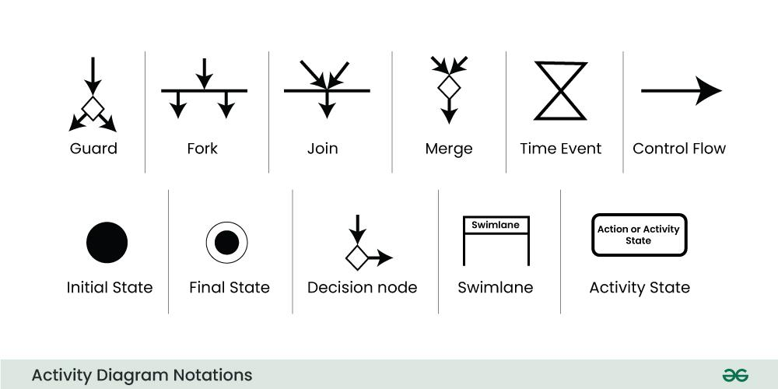

Fork
Fork nodes are used to support concurrent activities. When we use a fork node when both the activities get executed concurrently i.e. no decision is made before splitting the activity into two parts. Both parts need to be executed in case of a fork statement. We use a rounded solid rectangular bar to represent a Fork notation with incoming arrow from the parent activity state and outgoing arrows towards the newly created activities.
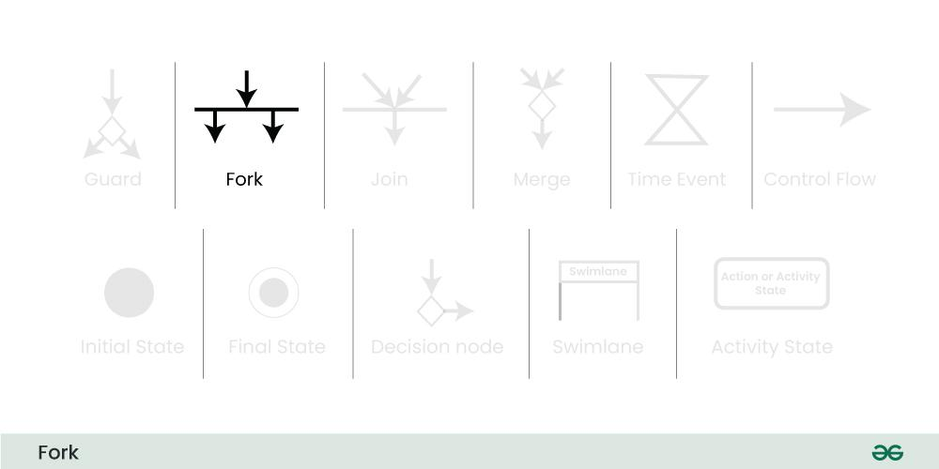
For example:
In the example below, the activity of making coffee can be split into two concurrent activities and hence we use the fork notation.

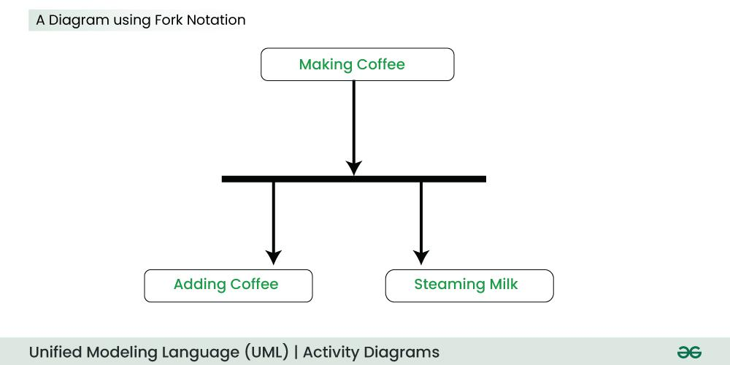7. Join
Join nodes are used to support concurrent activities converging into one. For join notations we have two or more incoming edges and one outgoing edge.
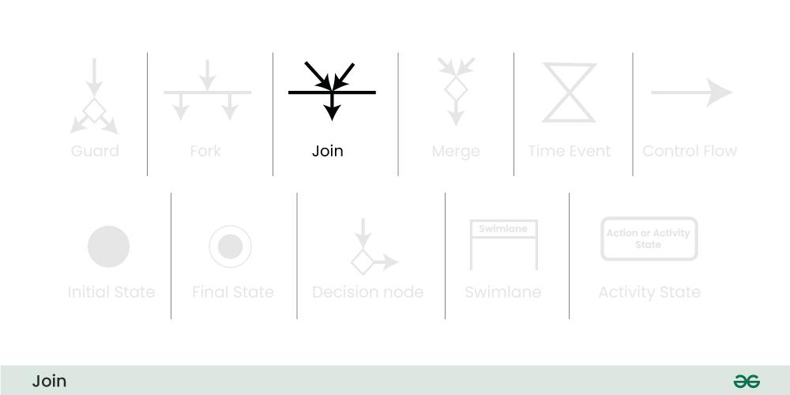
For example:
When both activities i.e. steaming the milk and adding coffee get completed, we converge them into one final activity.
